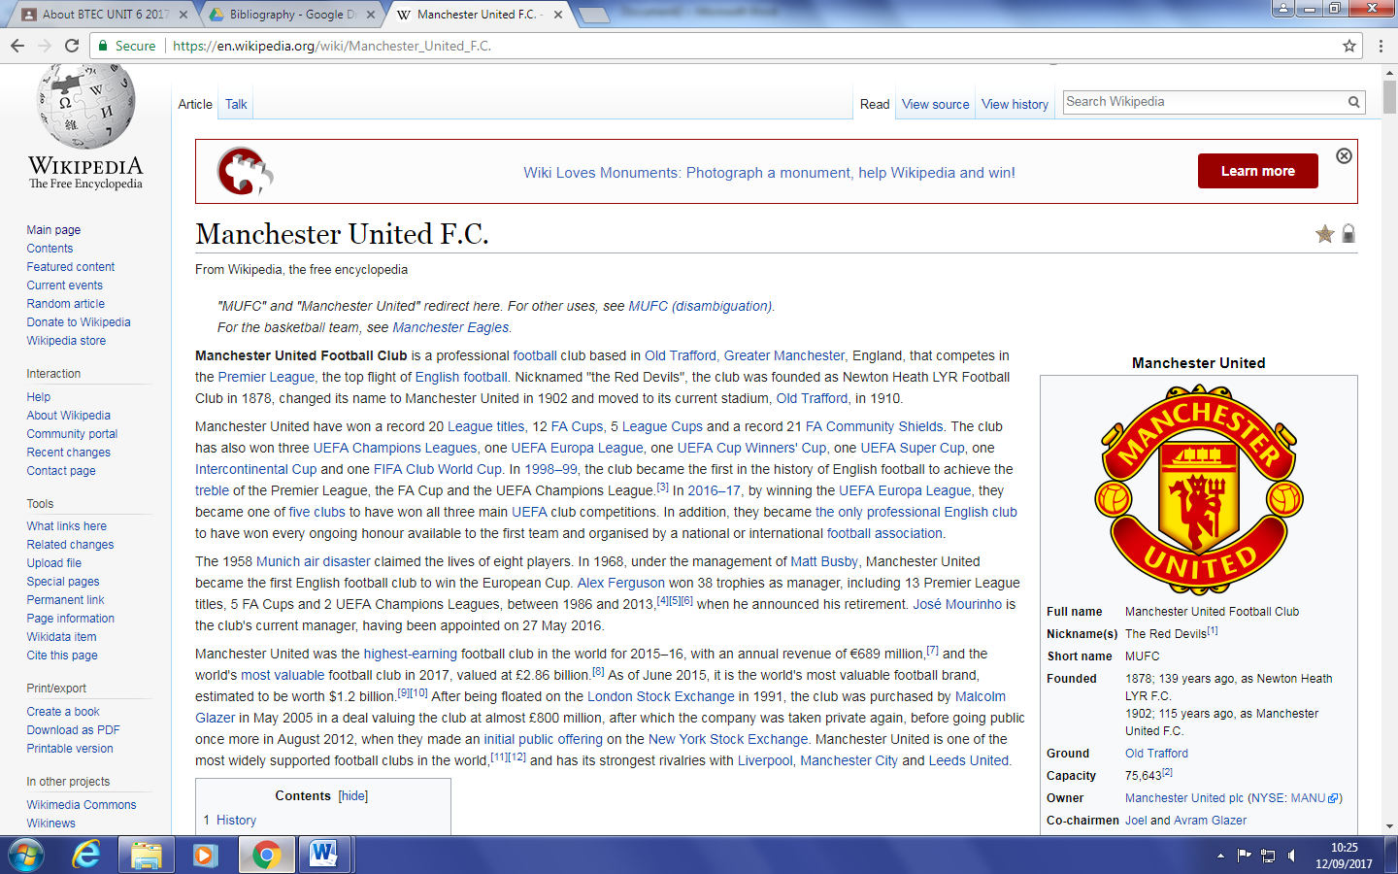

The wiki about Manchester united F.C. is very detailed and offers information in depth of every topic about the club including history, trophies, kit and origin as well as the present day. It has lots of images of the club badges and different